EE 546C Lab 7

Sensor Evaluation

May 15 at ECE137B

Learning objectives:
- Evaluate the characteristics and performance of the Velostat-based pressure sensing system, including repeatability, hysteresis, crosstalk, frame rate, and adaptability to customized application scenarios.
- Each group could also work on developing a customized visualization interface based on their specific application.

Materials:
- Your laptop
- Lab kit

Tools will be provided:
- Calibration weights: 10g, 20g, 50g, 100g, 200, 500g
- Multimeter, oscilloscope, power supply
- Soldering station
- Scissors, wire strippers, IDC cables, crimpers, etc

Sensor evaluation:
*Tips: Visualization for all sensing points with data recording

The following visualization method might help you in the process of evaluating your sensor. This visualization is only for your reference, you can develop your own way to finish the following 5 tasks.

This visualization interface was developed using Python to display the real-time voltage readings of each sensing point and save the data in a .csv file. For example, in the case of a 4×4 pressure sensor, the visualization interface shows 16 voltage curves corresponding to the 16 sensing points. When a specific point is pressed, its voltage curve drops immediately, and the voltages of other points may also be affected to varying degrees. The recorded data can be used for further processing and analysis.

Video:

16 points voltage-weight.mp4

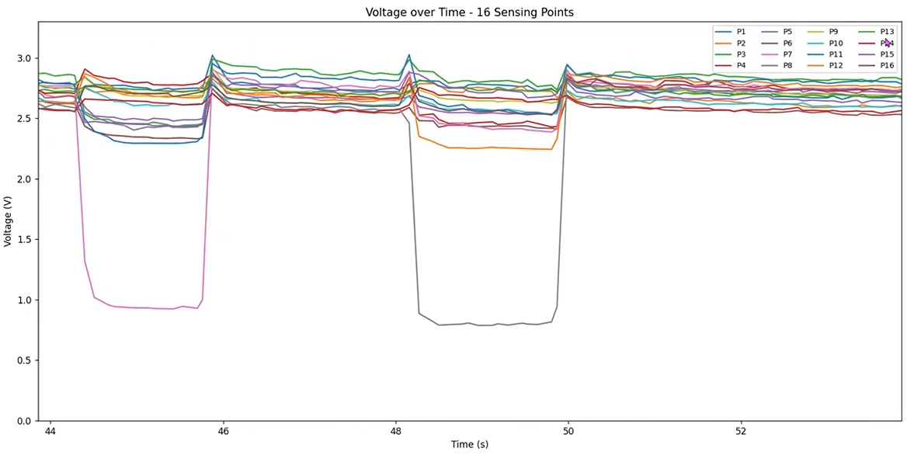

Tasks:
You can design your own way to finish these tasks. For delivering the result for each task, you can consider plotting graphs based on the data you have collected. Then document your results in the digital lab notebook.
- Consistency Evaluation Under Repeated Pressure
Test and analyze whether applying the same pressure multiple times to the same sensing point yields similar sensor readings.

- Graph of the Relationship Between Sensor Voltage/Resistance and Pressure During the Loading and Unloading Processes

For one or some selected sensing points, place weights of different masses to test the relationship between the sensor readings and the applied pressure. You can try gradually increasing the weight and then decreasing it to observe whether there is any hysteresis in the sensor's resistance values during the loading and unloading processes.

Hysteresis: when pressure is applied to and then released from the Velostat material, its resistance values during the loading (pressing) and unloading (releasing) processes may not be exactly the same. Even under the same pressure, the sensor’s readout may differ.

Example: Hysteresis from a Single Sensing Point
The figure below shows the sensor readout from a single sensing point as weights of 0g, 10g, 20g, 50g, 100g, 50g, 20g, 10g, and 0g were sequentially placed on it. This process was repeated three times. During each cycle, a loading phase was followed immediately by an unloading phase, and hysteresis can be observed during the unloading process.
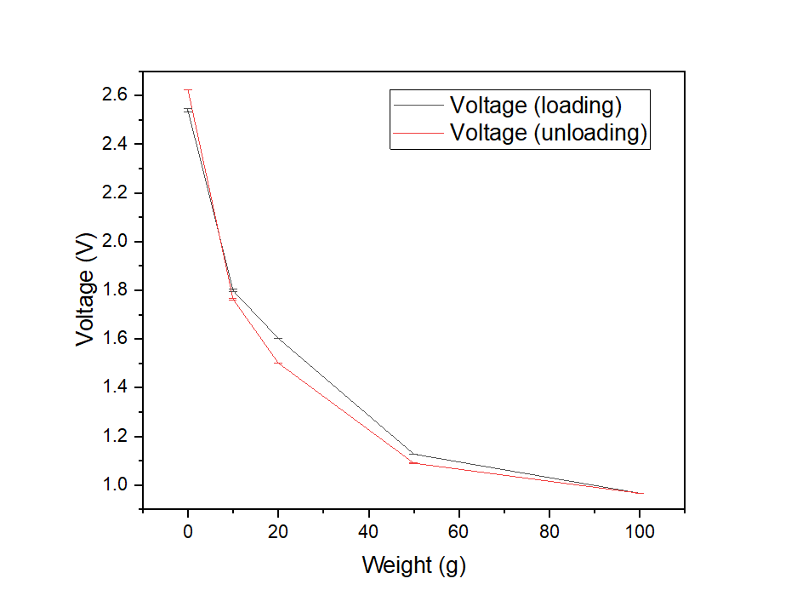
- Analyze the system's crosstalk.
To test for crosstalk, apply pressure to a single sensing point and observe the voltage response of other points. Significant changes in unpressed points may indicate electrical or mechanical coupling.
Please analyze whether crosstalk exists in your system and assess its severity.

- Frame rate
Testing the frame rate of the system refers to measuring how many complete sensor matrix readings the system can acquire and visualize per second, expressed in fps (frames per second). This is crucial for evaluating the system's real-time performance and response speed.
Common frame rate bottlenecks include:
- ESP32 scanning speed: Determined by multiplexer control and ADC sampling rate.
- Serial transmission rate: Controlled by the baud rate (e.g., 115200, 250000), which limits data transfer speed.
- Python/PC visualization refresh rate: Affected by the update interval of graphical libraries such as Matplotlib or Tkinter.
In addition to serial communication, the ESP-WROOM-32 development board (microcontroller board) also supports data transmission via Bluetooth and Wi-Fi. You are encouraged to explore these options and evaluate the framerate of different transmission methods.

- Customized Testing:
Design a testing procedure tailored to your specific application scenario to verify whether the current sensor meets the required performance.
For example,
- Evaluate whether the sensor's resolution and sensitivity are sufficient for your application;
- Whether the sensor is flexible enough if bending is required;
- Whether the connection between the sensing matrix and the cables is secure;
- Whether wireless data transmission is needed.

Check Point 3:
By the end of Lab 7, each team's basic heatmap visualization of the sensing system’s readout will be reviewed by TA.

Notebook Update 3 DDL:
May 18, 23:59. The contents for lab 5 and 6 will be checked.
Please remember to state each member’s contribution.

